**mAP(mean Average Precision)**

$$precision=\frac{TP}{TP+FP}=\frac{Acc TP}{Acc Detections}$$

$$recall=\frac{TP}{TP+FN}=\frac{Acc TP}{All Ground Truths}$$

TP：与ground truth的IoU> ${IOU}_{threshold}$ 且IoU最大的检测框，其中ground truth为与检测框IoU最大的，下同

FP：与ground truth的IoU $≤{IOU}_{threshold}$ 或非IoU最大的检测框

FN：与所有预测框的IoU都小于 ${IOU}_{threshold}$ 的ground truth

取每个类别的ground truth，负责检测该类别的grid cell和其中的预测框，根据confidence变化，分别以recall和precision为横纵坐标绘制一条P-R曲线，AP为该曲线下的面积 $$AP=\sum_{n}{\left({\tilde{r}}_{n+1}-{\tilde{r}}_{n}\right)Precision\left({\tilde{r}}_{n+1}\right)}$$

规定 ${\tilde{r}}_{0}=0，{\tilde{r}}_{n+1}=\underset{r:r>{\tilde{r}}_{n}}{argmax}{Precision\left(r\right)}$

mAP就是各类别的AP的平均值

$$mAP=\frac{1}{|classes|}\sum_{c∈classes}{AP(c)} * 100\%$$

**计算AP例子**

有7张图片Iamge1-7，共15个目标(绿色)，24个检测框(红色)，每个检测框都有A-Y的编号和置信度

如果规定IoU>0.3且IoU最大的检测框的为TP，IoU $≤$ 0.3的为FP

可以列出如下表格

|  |  |  |  |
| --- | --- | --- | --- |
| Images | Detections | Confidences | TP or FP |
| Image1 | A | 88% | FP |
| Image1 | B | 70% | TP |
| Image1 | C | 80% | FP |
| Image2 | D | 71% | FP |
| Image2 | E | 54% | TP |
| Image2 | F | 74% | FP |
| Image3 | G | 18% | TP |
| Image3 | H | 67% | FP |
| Image3 | I | 38% | FP |
| Image3 | J | 91% | TP |
| Image3 | K | 44% | FP |
| Image4 | L | 35% | FP |
| Image4 | M | 78% | FP |
| Image4 | N | 45% | FP |
| Image4 | O | 14% | FP |
| Image5 | P | 62% | TP |
| Image5 | Q | 44% | FP |
| Image5 | R | 95% | FP |
| Image5 | S | 23% | TP |
| Image6 | T | 45% | FP |
| Image6 | U | 84% | FP |
| Image6 | V | 43% | FP |
| Image7 | X | 48% | TP |
| Image7 | Y | 95% | FP |

根据置信度从大到小排序所有的预测框，然后就可以计算 Precision 和 Recall 的值

|  |  |  |  |  |  |  |  |  |  |
| --- | --- | --- | --- | --- | --- | --- | --- | --- | --- |
| Images | Detections | Confidences | TP | FP | AccTP | AccFP | Precision | Recall | num |
| Iamge5 | R | 95% | 1 | 0 | 1 | 0 | 1 | 0.0666 | 1 |
| Iamge7 | Y | 95% | 0 | 1 | 1 | 1 | 0.5 | 0.0666 | 2 |
| Iamge3 | J | 91% | 1 | 0 | 2 | 1 | 0.6666 | 0.1333 | 3 |
| Iamge1 | A | 88% | 0 | 1 | 2 | 2 | 0.5 | 0.1333 | 4 |
| Iamge6 | U | 84% | 0 | 1 | 2 | 3 | 0.4 | 0.1333 | 5 |
| Iamge1 | C | 80% | 0 | 1 | 2 | 4 | 0.3333 | 0.1333 | 6 |
| Iamge4 | M | 78% | 0 | 1 | 2 | 5 | 0.2857 | 0.1333 | 7 |
| Iamge2 | F | 74% | 0 | 1 | 2 | 6 | 0.25 | 0.1333 | 8 |
| Iamge2 | D | 71% | 0 | 1 | 2 | 7 | 0.222 | 0.1333 | 9 |
| Iamge1 | B | 70% | 1 | 0 | 3 | 7 | 0.3 | 0.2 | 10 |
| Iamge3 | H | 67% | 0 | 1 | 3 | 8 | 0.2727 | 0.2 | 11 |
| Iamge5 | P | 62% | 1 | 0 | 4 | 8 | 0.3333 | 0.2666 | 12 |
| Iamge2 | E | 57% | 1 | 0 | 5 | 8 | 0.3846 | 0.3333 | 13 |
| Iamge7 | X | 48% | 1 | 0 | 6 | 8 | 0.4285 | 0.4 | 14 |
| Iamge4 | N | 45% | 0 | 1 | 6 | 9 | 0.4 | 0.4 | 15 |
| Iamge6 | T | 45% | 0 | 1 | 6 | 10 | 0.375 | 0.4 | 16 |
| Iamge3 | K | 44% | 0 | 1 | 6 | 11 | 0.3529 | 0.4 | 17 |
| Iamge5 | Q | 44% | 0 | 1 | 6 | 12 | 0.3333 | 0.4 | 18 |
| Iamge6 | V | 43% | 0 | 1 | 6 | 13 | 0.3517 | 0.4 | 19 |
| Iamge3 | I | 38% | 0 | 1 | 6 | 14 | 0.3 | 0.4 | 20 |
| Iamge4 | L | 35% | 0 | 1 | 6 | 15 | 0.2857 | 0.4 | 21 |
| Iamge5 | S | 23% | 0 | 1 | 6 | 16 | 0.2727 | 0.4 | 22 |
| Iamge3 | G | 18% | 1 | 0 | 7 | 16 | 0.3043 | 0.4666 | 23 |
| Iamge4 | O | 14% | 0 | 1 | 7 | 17 | 0.2916 | 0.4666 | 24 |

Precision和Recall的计算方式：

num为1：Precision=1/1=1，Recall=1/15=0.0666

num为2：Precision=1/2=0.5，Recall=1/15=0.0666

num为3：Precision=2/3=0.6666，Recall=2/15=0.133

依此类推，可绘出P-R曲线

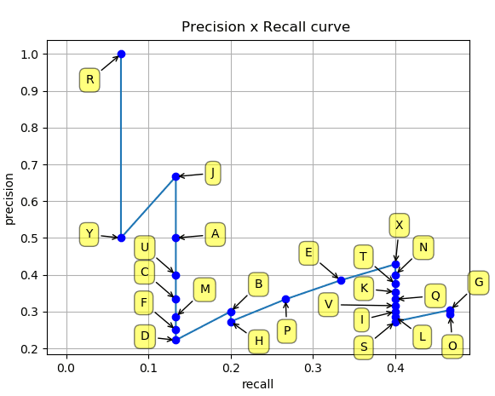

计算AP，直观上来说，可从 ${\tilde{r}}_{0}=0$ 开始，找到其之后Precision最大的点 ${\tilde{r}}_{1}$，作平行于R轴的线，再找到 ${\tilde{r}}_{1}$ 之后最大的点 ${\tilde{r}}_{2}$，继续作平行线，直到没有剩余的(R,P)点存在

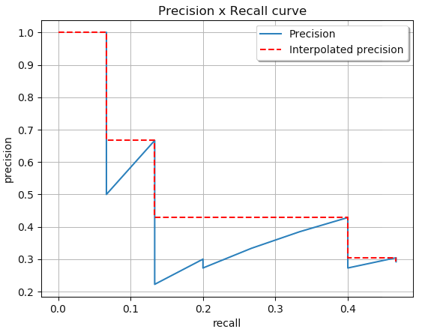

计算面积